**Get Guidance**

**PROJECT SYNOPSIS**

OF MAJOR PROJECT

**BACHELOR OF TECHNOLOGY**

CSE

SUBMITTED BY

Navdeep Singh, Sukhanpreet Singh and Ramandeep Singh

1914627, 1914650 and 1914640

****

**CGC COLLEGE OF ENGINEERING, LANDRAN, MOHALI**

**INDEX**

|  |  |  |
| --- | --- | --- |
| **SR No.** | **Content** | **Page No** |
| **1** | Introduction | **3-5** |
| **2** | Feasibility Study | **6** |
| **3** | Methodology/Planning of work | **7** |
| **4** | Facilities required for the proposed work and Bibliography | **8** |

**Introduction**

Introducing a MERN based web application named as ‘Taza Khabar’. This Web App is developed to solve the problem of getting quick updates and headlines of the latest news. This web app will be a perfect site for anyone who wants to stay updated. Some features of the web app are:

* Getting latest news headlines.
* Read the whole article on a single click.
* Read news by categories.
* Categories includes Entertainment, Science, Business, Technology, General and Sports.
* Information about sources of the news.

**Technology Used**

**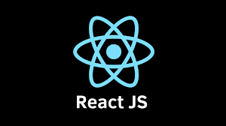**

**React Js** – This web app uses React Js for the frontend part. React is a **JavaScript** library created by **Facebook**. React is a **User Interface** (UI) library. React is a tool for building **UI components**

**React** (also known as **React.js** or **ReactJS**) is a [free and open-source](https://en.wikipedia.org/wiki/Free_and_open-source_software) [front-end](https://en.wikipedia.org/wiki/Front_end_and_back_end) [JavaScript library](https://en.wikipedia.org/wiki/JavaScript_library) for building [user interfaces](https://en.wikipedia.org/wiki/User_interfaces) based on UI components. It is maintained by [Meta](https://en.wikipedia.org/wiki/Meta_Platforms) (formerly Facebook) and a community of individual developers and companies. React can be used as a base in the development of [single-page](https://en.wikipedia.org/wiki/Single-page_application), mobile, or server-rendered applications with frameworks like [Next.js](https://en.wikipedia.org/wiki/Next.js).

****

This project uses Chakra-UI for the front end. **Chakra UI** is a simple, modular and accessible component library that gives you the building blocks you need to build your React applications.

**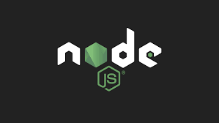**

**Node Js**- It used Node Js for the backend part.

* Node.js is an open source server environment
* Node.js is free
* Node.js runs on various platforms (Windows, Linux, UNIX, Mac OS X, etc.)
* Node.js uses JavaScript on the server

**Node.js** is an [open-source](https://en.wikipedia.org/wiki/Open-source_software), [cross-platform](https://en.wikipedia.org/wiki/Cross-platform), [back-end](https://en.wikipedia.org/wiki/Front_end_and_back_end) [JavaScript](https://en.wikipedia.org/wiki/JavaScript) [runtime environment](https://en.wikipedia.org/wiki/Runtime_system) that runs on the [V8 engine](https://en.wikipedia.org/wiki/V8_(JavaScript_engine)) and executes JavaScript code outside a [web browser](https://en.wikipedia.org/wiki/Web_browser). Node.js lets developers use JavaScript to write command line tools and for [server-side scripting](https://en.wikipedia.org/wiki/Server-side_scripting)—running scripts server-side to produce [dynamic web page](https://en.wikipedia.org/wiki/Dynamic_web_page) content before the page is sent to the user’s web browser. Consequently, Node.js represents a “JavaScript everywhere” paradigm,[[6]](https://en.wikipedia.org/wiki/Node.js" \l "cite_note-6) unifying [web-application](https://en.wikipedia.org/wiki/Web_application) development around a single programming language, rather than different languages for server-side and client-side scripts.

Our website uses also express js.

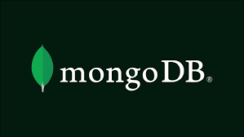

**MongoDB** – MongoDB is an open source [NoSQL](https://www.techtarget.com/searchdatamanagement/definition/NoSQL-Not-Only-SQL) database management program. NoSQL is used as an alternative to traditional relational databases. NoSQL databases are quite useful for working with large sets of distributed data. MongoDB is a tool that can manage document-oriented information, store or retrieve information.

****

**Chakra UI:** Chakra UI is a simple, modular and accessible component library that gives you the building blocks you need to build your React applications.

**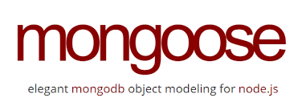**

**Mongoose:** Mongoose provides a straight-forward, schema-based solution to model your application data. It includes built-in type casting, validation, query building, business logic hooks and more, out of the box.

****

**Express Js:** Express is a minimal and flexible Node.js web application framework that provides a robust set of features for web and mobile applications.

**Working**

**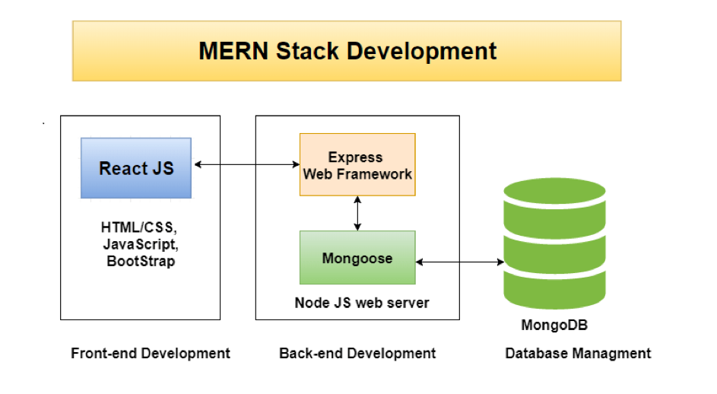**

**Figure 1**

The above diagram shows how the frontend part and backend part.

**Feasibility Study**

**A feasibility study is simply an assessment of the practicality of a proposed project plan or method**. This is done by analysing technical, economic, legal, operational and time feasibility factors.

* **Technical Feasibility: -** This project requires the MERN Stack technologies and a MERN stack developer and it is easily available. So this project is completely technical feasible.
* **Economic Feasibility: -** Deployment of this project requires web hosting for the commercial purpose. But for the trial purpose, it will be uploaded on the ‘Heroku’ Platform which is completely free.
* **Time Feasibility:-**Development and Deployment will be done in a timely manner.Development phase will be completed in 2 – 3 months and deployment requires 2-3 days only.

**Need of Project**

* Till Now there is no integrated platform to provide communication between seniors and juniors.
* This web app has separate section for writing article so that students who are good at academics can share the resources, content and much more.
* Real time updates of College Events, recruitments.

**Significance of Project**

The significance of the project is to provide the following benefits:

* Easy Communication between students.
* Interests Section – For the students having interests in same TECH/FIELD.
* Updates of Events, holidays, recruitments etc.
* Article writing Facility
* Fully responsive

**Methodology/Planning of work**

The development of the project involves various phases that are elaborated below:

**Development of the frontend (UI): -** First step to develop this project is to develop the attractive and fast UI for the students. UI of this project will be based on the React Js. Developing the UI will take approximately 15 days of time.

**Development of the backend (Database and middleware):-** After the development of the UI, next step is to create the database for the project and developing the middleware to connect the frontend part with the backend. MongoDB and Node Js will be used for this purpose respectively.

**Deployment of the project: -** This phase requires the deployment of the project on the Web Hosting platform.

**Sharing:-** Web app will be shared among the users

**Facilities required for the proposed work**

The software/tools and the hardware required for this project are

**Software/Tools**

* Text Editor – Vs Code
* NPM
* POSTMAN – for testing APIs
* Node Js
* MongoDB Compass – for managing database

**Hardware**

The following table lists the minimum and recommended hardware requirements for the web application.

| **Component** | **Minimum** | **Recommended** |
| --- | --- | --- |
| 1. Processor | 1.9 gigahertz (GHz) x86- or x64-bit dual core processor with SSE2 instruction set | 3.3 gigahertz (GHz) or faster 64-bit dual core processor with SSE2 instruction set |
| 1. Memory | 2-GB RAM | 4-GB RAM or more |
| 1. Display | Super VGA with a resolution of 1024 x 768 | Super VGA with a resolution of 1024 x 768 |

**Bibliography**

<https://stackoverflow.com/>

<https://chakra-ui.com/>

<https://reactjs.org/>

<https://nodejs.org/>

<https://www.mongodb.com/>

<https://www.npmjs.com/>

<https://www.youtube.com/>